Vanier College

Faculty of Science and Technology

System Development

420-436-VA

Mar. 8th, 2023

Deliverable 3

Green Team

Mert Kairstan Salvador

Maxym Galenko

Ali Raza

In collaboration with Marco Patulli

(Code from our eCommerce class will be used for certain features of this project)

We, the green team, certify that this assignment is our own work.

I, Mert Kairstan Salvador, student ID #2179970, certify that I have contributed to this deliverable, M.K.S.

I, Maxym Galenko, student ID #2060352, certify that I have contributed to this deliverable, M.G.

I, Ali Raza, student ID #2080455, certify that I have contributed to this deliverable, A.R.

# Executive Overview

_____________________________________________________________________________________

Our project is a prototype e-Commerce Project web application for a client. Our client is Marco who is a small personal computer business owner located in Montreal. He offers laptops, pc builds and commissions.

In this deliverable, we learned a lot more about our client and his business, we had more meetings with him during which we asked him questions about how everything he keeps track of his inventory, the issues he was facing on inventory, about payment methods and his advertisement methods. This meeting helped us understand how he keeps his business working and the problems that he occasionally faces. This interview was a crucial part of our documentation for this deliverable.

In short, we mostly remain the same. The main issue that he needs to fix is the inventory management seeing as he uses excel sheets to keep track of as little information as possible, as well as keep the builds all in his head. Another inconvenience that he faces is listing all his products online. Limiting the advertisement opportunity as he only advertises on Instagram. Seeing as our client only accepts cash and wire transactions, we have decided to introduce an automatic payment method to facilitate the method.

Following the business problems, this document discusses the processes that client-side, server-side/admin must follow to run the business smoothly. It describes how a client may add items to their cart and go through the checkout process which then updates the database and allows the seller to view, fulfill and mark the order as shipped. It also describes the two ways that a customer may contact the seller and how the seller may send promotional emails to the clients.

# Summary of the Client

_____________________________________________________________________________________

Marco Patulli is a college student whose main source of income is his business. He started this business due to his love for building PCs/laptops and saw it as an opportunity to combine his passion and work in order to make money.

Our client is growth oriented and knows the value of having a website for the growth of his business. He understands the uses of Facebook marketplace and his Instagram page but knows that they have a limited reach. The website would allow him to manage his inventory and facilitate client orders.

His computer skills are limited to assembling computers, browsing, MS Office and other PC applications that are used for PC performance. Given his knowledge of these applications and that he is enrolled in the Computer Science program, he shouldn’t have any problem using the website with proper instruction.

Currently our client uses excel sheets to track his inventory which causes problems when he sells PCs and buys parts. He doesn’t have a way to track his income and expenses.

# Business Problem

_____________________________________________________________________________________

Now that we have finished the UML diagram and Use Case Templates, The Flow Chart as well as the class diagram, we can better understand the precise business problems our client has.

The first business problem we must deal with is the inventory management. Our client currently keeps track of his inventory using excel sheets. He doesn’t write a lot of information on the excel sheet besides the total cost of each computer component and he keeps the rest of the important details like money received, stock, customer build in his head. The website we are creating will have database that will solve this issue. We will store information about the customer, the computer components, and products in the database.

Another business problem that we are aiming to fix with our website is the limited way our client displays his products. The platform that Marco uses to display his merchandise is Instagram. Instagram isn’t a platform that specializes in selling products which means that when you make a post about your product, you can’t present it with all the details that you would need to attract customers. The website will fix this problem as it will display a product along with all the important details like the price, the description, and an image.

Finally, the last business problem that our website will solve for our client is the payment methods. Marco currently only accepts cash and transfers. His customers only pay him after they receive the product which can cause problems for Marco since he needs to build the PC/laptop before hand and spend money on getting the components only for the customer to back out. Allowing the customers to pay through our website will also provide funding for the build so that even if Marco doesn’t have money, he can still build the product with the advance payment. An online payment method will also protect our client from physical harm by people who would want to take advantage of him.

# Narrative Description of the Present Information System

_____________________________________________________________________________________

Customers of Marco’s PC Shop will soon have access to a website, instead of his Instagram profile. This means that, instead of visiting Instagram, our client’s customers will be able to visit an actual website where they will be able to sign up and buy items. Until that website is made, the way the system works is described below.

People who happen to stumble across Marco on Instagram, or people who know the business and actively reach out to that page are greeted by pictures of our clients’ products. They may browse freely on his Instagram page, and, to buy an item, customers must send him a private message through Instagram and discuss with him how they want their item customized, what parts they need resourced, or what laptops they need to get.

Following these discussions, our client works on the item and updates his inventory which is currently kept in excel sheets that he manually updates and then keeps the rest all in his head.

Once paid, he updates the same excel sheet with his transactions. Then go to get new products when on sale or available.

# Appendixes

_____________________________________________________________________________________

## Appendix 1:

Whole Overview

Head

## Appendix 2:

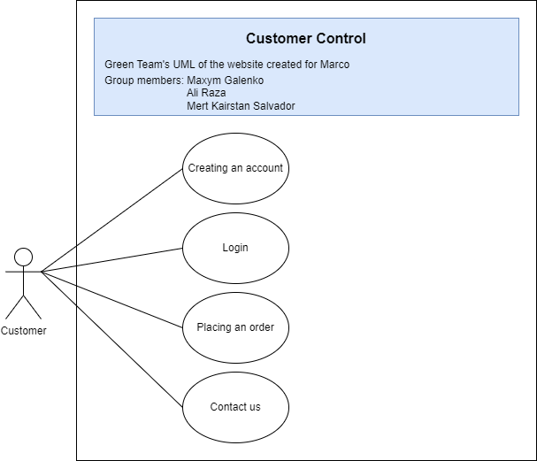

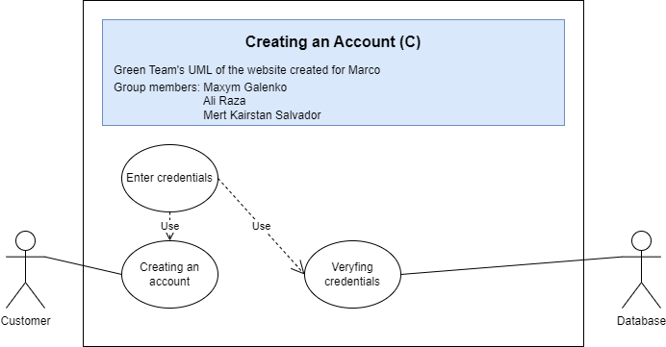

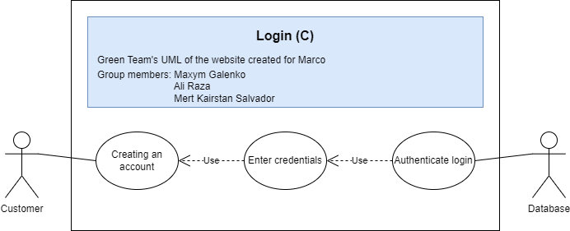

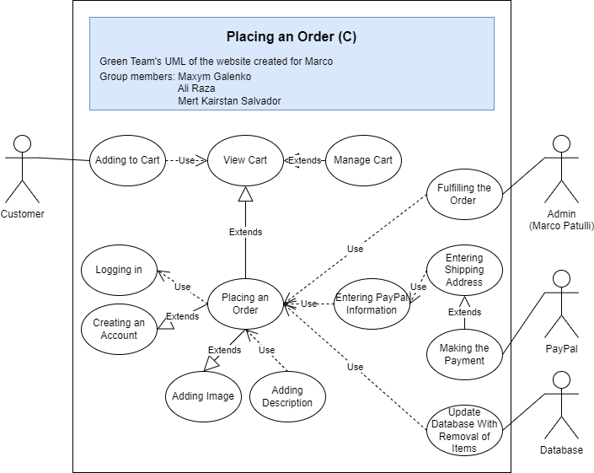

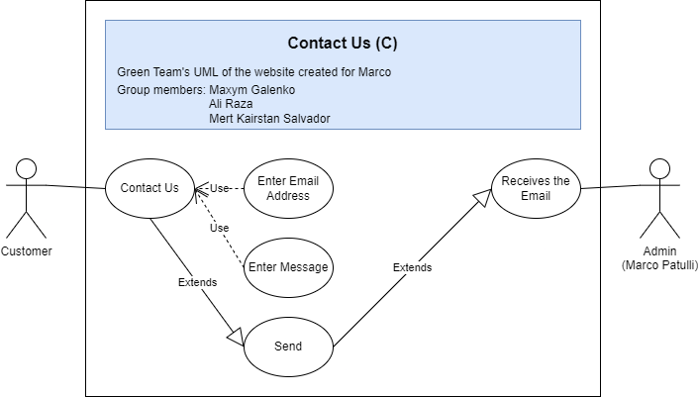

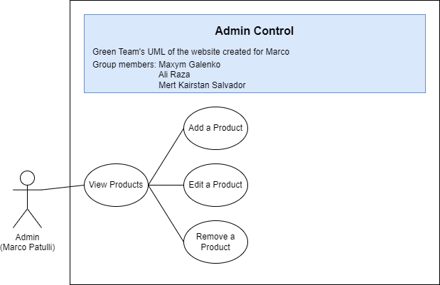

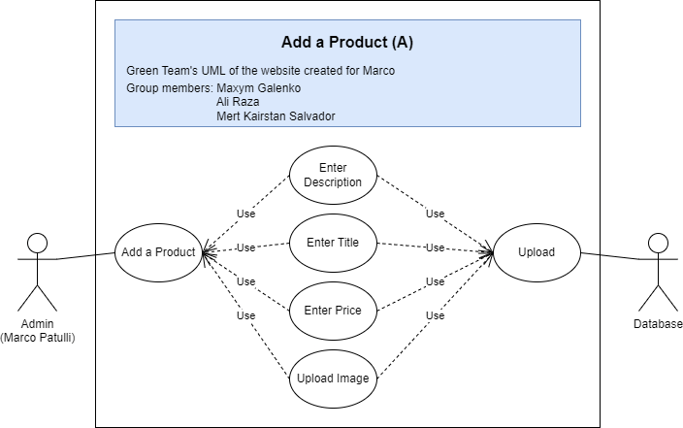

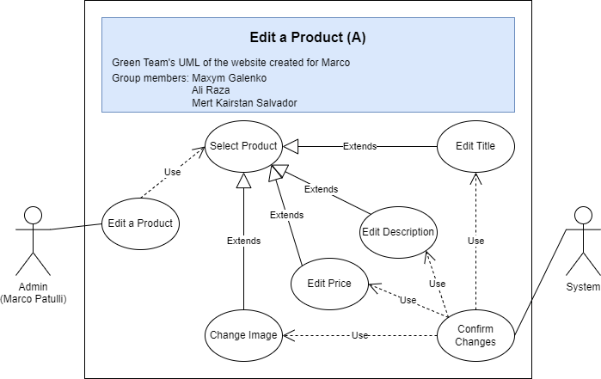

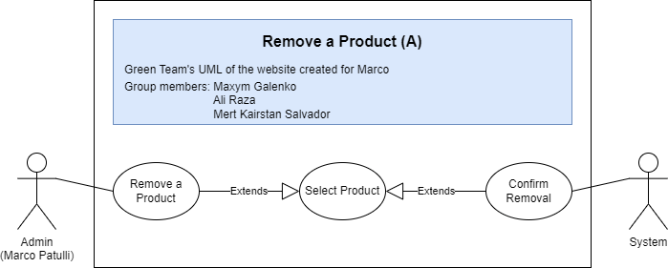

## Appendix 3:

|  |  |  |  |  |
| --- | --- | --- | --- | --- |
| **Use Case ID:** | CreateUserPage | | | |
| **Use Case Name:** | Creating a User | | | |
| **Created By:** | Ali Raza | | **Last Updated By:** | N/A |
| **Date Created:** | 03/03/2023 | | **Date Last Updated:** | N/A |
| **Actors:** | | Website’s customers (Primary)  Database, Admin (Secondary) | | |
| **Description:** | | This use case adds a new customer to the database | | |
| **Trigger** | | Customer fills out sign-up form | | |
| **Preconditions:** | | Customer lands on the website OR tries to checkout OR tries to login | | |
| **Postconditions:** | | 1- Customer’s information is saved in the database system  2- Customer can login | | |
| **Basic Workflow:** | | 1. Customer fills out the sign-up form  2. System checks if password verification passes  3. System adds the customer’s information to the database | | |
| **Alternative Workflow:** | | N/A | | |
| **Exceptions:** | |  | | |
| **Includes:** | | N/A | | |
| **Frequency of Use:** | | On demand | | |
| **Special Requirements:** | | N/A | | |
| **Assumptions:** | | Customer can fill up the sign-up form | | |

|  |  |  |  |  |
| --- | --- | --- | --- | --- |
| **Use Case ID:** | LoginPage | | | |
| **Use Case Name:** | Login | | | |
| **Created By:** | Ali Raza | | **Last Updated By:** | N/A |
| **Date Created:** | 03/03/2023 | | **Date Last Updated:** | N/A |
| **Actors:** | | Website’s customers (Primary)  Database, Admin (Secondary) | | |
| **Description:** | | This use case allows a returning customer to login to their account | | |
| **Trigger** | | Customer fills out the login form | | |
| **Preconditions:** | | 1- Customer has a valid account  2- Customer isn’t logged in | | |
| **Postconditions:** | | 1- The customer is logged into their account  2- The customer can checkout | | |
| **Basic Workflow:** | | 1. System requires user’s email and password  2. Customer fills out the login form  3. System authenticates the login | | |
| **Alternative Workflow:** | | 3a. If authentication fails but user DOES NOT have an account  1. System asks user if they want to create an account  -> Creating User (Extend CreateUserPage) | | |
| **Exceptions:** | | 3a. If authentication fails AND user has an account  1. System displays a message  2. Restarts from step 1 without being logged in | | |
| **Includes:** | | CreateUserPage | | |
| **Frequency of Use:** | | On demand | | |
| **Special Requirements:** | | N/A | | |
| **Assumptions:** | | Customer has a registered account.  Customer can fill out the sign-in form without issues | | |

|  |  |  |  |  |
| --- | --- | --- | --- | --- |
| **Use Case ID:** | ContactPage | | | |
| **Use Case Name:** | Contact Admin | | | |
| **Created By:** | Ali Raza | | **Last Updated By:** | N/A |
| **Date Created:** | 03/03/2023 | | **Date Last Updated:** | N/A |
| **Actors:** | | Customer (Primary)  Admin (Secondary) | | |
| **Description:** | | This use case allows website’s customers to send an email to  the admin for inquiry or their questions | | |
| **Trigger** | | The customer wants to contact the admin | | |
| **Preconditions:** | | 1- The customer is logged into their account | | |
| **Postconditions:** | | 1- The admin receives an email from the customer | | |
| **Basic Workflow:** | | 1. The customer navigates to the “Contact Us” page of the website  2. The system presents a form asking the customer for their email,  their name, their message  3. The customer fills out the form with their email  4. The system authenticates the email  5. The email is sent to the admin | | |
| **Alternative Workflow:** | | 2a. If the customer does not want to fill the form  1. The customer sees other ways to contact the admin at the  bottom of the page (Example: through Instagram or Facebook)  2. The customer personally contacts the admin | | |
| **Exceptions:** | | 4a. If the authentication fails  1. The system displays a message stating the email is not the  same as the one used to login.  2. The system requires the user to start over without sending  the email to the admin | | |
| **Includes:** | | CreateUserPage | | |
| **Frequency of Use:** | | On Demand | | |
| **Special Requirements:** | | N/A | | |
| **Assumptions:** | | The customer can fill out the contact form | | |

|  |  |  |  |  |
| --- | --- | --- | --- | --- |
| **Use Case ID:** | CheckoutWithCardPage | | | |
| **Use Case Name:** | Checking out with a card | | | |
| **Created By:** | Ali Raza | | **Last Updated By:** | N/A |
| **Date Created:** | 03/03/2023 | | **Date Last Updated:** | N/A |
| **Actors:** | | Customer (Primary)  Database, Bank, Admin (Secondary) | | |
| **Description:** | | This use case allows for a customer to buy the items in their cart and checkout | | |
| **Trigger** | | The customer clicks the “Proceed to Checkout with a Credit or Debit card button | | |
| **Preconditions:** | | 1- The customer has items in their cart | | |
| **Postconditions:** | | 1- The items in the cart are bought and paid for  2- The admin will receive the order  3- The admin can now fulfil the order | | |
| **Basic Workflow:** | | 1- Assuming the customer is on the page with their cart, the  customer clicks the “Proceed to Checkout with a Credit or Debit  card” button  2- The webpage redirects the customer to the checkout page.  3- The customer must enter their billing and shipping information  4- The customer clicks on “continue”  5- The customer is redirected to the website to finish the  Transaction  6- The customer clicks on “submit order”  7- A popup message confirms the order was placed.  8- The admin receives the money and order details | | |
| **Alternative Workflow:** | | 1a- If the user is not logged in and does not have an account  1. The user must create an account  -> Creating User (Extend CreateUserPage)  2. Proceed normally to step 2  1b- If the user is not logged in and has an account  1. The user must log into their account  -> Login (Extend LoginPage) | | |
| **Exceptions:** | | 5a. If customer puts invalid information for credit or debit card | | |
| **Includes:** | | LoginPage  CreateUserPage | | |
| **Frequency of Use:** | | On demand | | |
| **Special Requirements:** | | Customer must have a credit or debit card | | |
| **Assumptions:** | | Customer has a credit or debit card.  Customer is able to buy from the Admin.  Customer already has a cart with items they want to buy. | | |

|  |  |  |  |  |
| --- | --- | --- | --- | --- |
| **Use Case ID:** | CheckoutWithPaypalPage | | | |
| **Use Case Name:** | Checking out with PayPal | | | |
| **Created By:** | Ali Raza | | **Last Updated By:** | N/A |
| **Date Created:** | 03/03/2023 | | **Date Last Updated:** | N/A |
| **Actors:** | | Customer (Primary)  Database, PayPal, Admin (Secondary) | | |
| **Description:** | | This use case allows for a customer to buy the items in their cart  and checkout | | |
| **Trigger** | | The customer clicks the “Proceed to Checkout with PayPal” button | | |
| **Preconditions:** | | 1- The customer has items in their cart | | |
| **Postconditions:** | | 1- The items in the cart are bought and paid for  2- The admin will receive the order  3- The admin can now fulfil the order | | |
| **Basic Workflow:** | | 1- Assuming the customer is on the page with their cart, the  customer clicks the “Proceed to Checkout with PayPal” button  2- The webpage redirects the customer to the PayPal’s login page  3- The customer logs into their PayPal account  4- PayPal authenticates the login  5- PayPal ensures that the name, address, and preferred card are  correct  6- The customer clicks on “continue”  7- The customer is redirected to our website to finish the  transaction  8- The customer clicks on “submit order”  9- A popup message confirms the order was placed  10- The admin receives the money and order details | | |
| **Alternative Workflow:** | | 1a- If the user is not logged in and does not have an account  1. The user must create an account  -> Creating User (Extend CreateUserPage)  2. Proceed normally to step 2  1b- If the user is not logged in and has an account  1. The user must log into their account  -> Login (Extend LoginPage)  3a- If the user does not have a PayPal account   1. The customer shall make a PayPal account 2. Could opt to pay with credit card instead   -> Checkout with card (Extend CheckoutWithCardPage)  2. Proceed with step 4  4a- If the login fails  1. The website will display a message and not allow the login  to happen  2. The customer will have to enter proper credentials  3. Proceed normally with step 5  5a- If the name and address are incorrect  1. The user clicks “add a shipping address”  2. The user enters the correct shipping information  3. Proceed normally with step 6  5b- If the card being used is incorrect  1. The user clicks “add a debit or credit card”  2. The user adds the correct billing information  3. Proceed normally with step 6 | | |
| **Exceptions:** | | N/A | | |
| **Includes:** | | LoginPage  CreateUserPage | | |
| **Frequency of Use:** | | On demand | | |
| **Special Requirements:** | | Customer must have an account with PayPal | | |
| **Assumptions:** | | Customer has an account with PayPal  Customer is able to buy from the Admin  Customer already has a cart full with items they want to buy | | |

|  |  |  |  |  |
| --- | --- | --- | --- | --- |
| **Use Case ID:** | AddProductPage | | | |
| **Use Case Name:** | Adding a Product | | | |
| **Created By:** | Ali Raza | | **Last Updated By:** | N/A |
| **Date Created:** | 03/03/2023 | | **Date Last Updated:** | N/A |
| **Actors:** | | Admin (Primary)  Database (Secondary) | | |
| **Description:** | | This use case allows for the admin to add a product to the database for sale | | |
| **Trigger** | | The admin adds a new product for sale | | |
| **Preconditions:** | | N/A | | |
| **Postconditions:** | | A product will be added to the website for sale  The database of products will be updated with a new product for sale | | |
| **Basic Workflow:** | | 1- The admin goes into the admin control page  2- The button “add product” is clicked  3- An empty form is displayed on the screen  4- The admin is required to upload a picture of the product, the product ID, the name, price, description, and quantity available of the specified product  5- The admin clicks on “post new product to website” button | | |
| **Alternative Workflow:** | | 5a- If any of the information was not added into the form  1. The web app displays a message  2. The admin is required to redo this step without the product being posted to the website  3. Continue normally to step 5  5b- If the admin no longer wishes to post a new product for sale  1. The admin clicks on “cancel upload”  2. The web app brings the admin back to the control page without  uploading the new product | | |
| **Exceptions:** | | 5b | | |
| **Includes:** | | N/A | | |
| **Frequency of Use:** | | On demand | | |
| **Special Requirements:** | | N/A | | |
| **Assumptions:** | | The admin can fill out the form  The admin is logged in with their administrative credentials | | |

|  |  |  |  |  |
| --- | --- | --- | --- | --- |
| **Use Case ID:** | UpdateProductPage | | | |
| **Use Case Name:** | Updating a Product | | | |
| **Created By:** | Ali Raza | | **Last Updated By:** | N/A |
| **Date Created:** | 03/03/2023 | | **Date Last Updated:** | N/A |
| **Actors:** | | Admin (Primary)  Database (Secondary) | | |
| **Description:** | | This use case allows for the admin to edit a product for sale | | |
| **Trigger** | | A product is changed slightly and needs an edit on the website | | |
| **Preconditions:** | | The product is listed with certain information and exists in the database | | |
| **Postconditions:** | | The product is listed with different information  The database is updated | | |
| **Basic Workflow:** | | 1- The admin goes into the admin control page  2- The “Update Product” button is clicked  3- The product that is to be updated is clicked  4- A form that is pre-filled with the product’s details is displayed on  the screen  5- The admin must change the uploaded picture of the product, the name, price, or description of the specified product  6- The admin clicks on “update product” button | | |
| **Alternative Workflow:** | | 6a- If any of the information was removed and not added back into  the form  1. The web app displays a message  2. The admin is required to redo this step without the product  being posted to the website  3. Continue normally to step 5  6b - If the admin no longer wishes to update the product  1. The admin clicks “cancel product” | | |
| **Exceptions:** | | 6b | | |
| **Includes:** | | N/A | | |
| **Frequency of Use:** | | On Demand | | |
| **Special Requirements:** | | N/A | | |
| **Assumptions:** | | The admin can fill out the form  The admin is logged in with their administrative credentials | | |

|  |  |  |  |  |
| --- | --- | --- | --- | --- |
| **Use Case ID:** | RemoveProductPage | | | |
| **Use Case Name:** | Remove Product | | | |
| **Created By:** | Ali Raza | | **Last Updated By:** | N/A |
| **Date Created:** | 03/03/2023 | | **Date Last Updated:** | N/A |
| **Actors:** | | Admin (Primary)  Database (Secondary) | | |
| **Description:** | | This use case allows the admin to remove a product for sale | | |
| **Trigger** | | A product is no longer offered to buy, either sold or removed | | |
| **Preconditions:** | | A product is listed on the website | | |
| **Postconditions:** | | The specified product is no longer listed on the website  The database is updated | | |
| **Basic Workflow:** | | 1- The admin goes into the admin control page  2- The admin clicks on “Remove a Product”  3- The product that is to be removed is clicked on and highlighted  4- A confirmation appears on the screen  5- The admin clicks “I am sure I want to delete this product”  6- A message of successful removal is displayed | | |
| **Alternative Workflow:** | | 5a- If the admin no longer wishes to remove the listing  1. The admin clicks “keep product”  2. The product remains on the page and no product is  removed from the website | | |
| **Exceptions:** | | 5a | | |
| **Includes:** | | N/A | | |
| **Frequency of Use:** | | On Demand | | |
| **Special Requirements:** | | N/A | | |
| **Assumptions:** | | The admin is logged in with their administrative credentials | | |

|  |  |  |  |  |
| --- | --- | --- | --- | --- |
| **Use Case ID:** | ManageOrdersPage | | | |
| **Use Case Name:** | Managing Orders | | | |
| **Created By:** | Ali Raza | | **Last Updated By:** | N/A |
| **Date Created:** | 03/03/2023 | | **Date Last Updated:** | N/A |
| Actors: | | Admin (Primary)  Database (Secondary) | | |
| **Description:** | | This use case allows the admin to view and manage all orders | | |
| **Trigger** | | The admin would like to view or manage the orders that have come in from the customers | | |
| **Preconditions:** | | The admin has orders they have not reviewed/fulfilled yet | | |
| **Postconditions:** | | The admin has the information they need about orders and has managed them  The database is updated | | |
| **Basic Workflow:** | | 1- The admin navigates to their admin control page  2- The admin must click on the “view orders” button  3- The admin can now view all their orders in list form  4- To view details and manage an order, the admin may click on  the order  5- A page with all the order details is displayed  6- The admin may mark the order as being worked on or in transit | | |
| **Alternative Workflow:** | | N/A | | |
| **Exceptions:** | | N/A | | |
| **Includes:** | | N/A | | |
| **Frequency of Use:** | | On Demand | | |
| **Special Requirements:** | | The admin is logged in through the admin credentials | | |
| **Assumptions:** | | N/A | | |

|  |  |  |  |  |
| --- | --- | --- | --- | --- |
| **Use Case ID:** | EditProfilePage | | | |
| **Use Case Name:** | Editing Customer’s Profile | | | |
| **Created By:** | Ali Raza | | **Last Updated By:** | N/A |
| **Date Created:** | 03/03/2023 | | **Date Last Updated:** | N/A |
| **Actors:** | | Customer (Primary)  Database (Secondary) | | |
| **Description:** | | This use case allows the user to edit the information on their profile, such as their address, payment information, name, etc | | |
| **Trigger** | | The customer would like to change their information | | |
| **Preconditions:** | | The customer has information that is no longer accurate on their profile | | |
| **Postconditions:** | | The customer now has newer, more accurate information in their profile  The database is updated with the customer’s new information | | |
| **Basic Workflow:** | | 1- The customer navigates to the “My Profile” page  2- On the page, the customer clicks “Edit my Information”  3- An already filled out form is displayed  4- The customer may edit their information  5- The customer clicks “Save”  6- A confirmation is prompted from the website  7- The customer clicks “I confirm this information is correct”  8- The information is changed on the customer’s profile | | |
| **Alternative Workflow:** | | 7a- If the information is not correct  1. The customer clicks “Changes need to be made”  2. Continue normally from step 3  7b- If the customer no longer wishes to update their profile  1. The customer clicks “cancel”  2. The changes are not updated and the customer is redirected to the “My Profile” page | | |
| **Exceptions:** | | 7b | | |
| **Includes:** | | N/A | | |
| **Frequency of Use:** | | On Demand | | |
| **Special Requirements:** | | N/A | | |
| **Assumptions:** | | The customer is able to fill out the form | | |

|  |  |  |  |  |
| --- | --- | --- | --- | --- |
| **Use Case ID:** | RemoveFromCartPage | | | |
| **Use Case Name:** | Removing Item from Cart | | | |
| **Created By:** | Ali Raza | | **Last Updated By:** | N/A |
| **Date Created:** | 03/03/2023 | | **Date Last Updated:** | N/A |
| **Actors:** | | Customer (Primary) | | |
| **Description:** | | This use case allows the user to remove an item from their cart  before proceeding to checkout | | |
| **Trigger** | | The customer would like to remove an item from their cart | | |
| **Preconditions:** | | The customer has items in their cart that they no longer would like  to buy | | |
| **Postconditions:** | | The specified item is no longer in their cart | | |
| **Basic Workflow:** | | 1- The customer navigates to the “My cart” page  2- The customer clicks on an item in their cart which they no longer desire to buy  3- The customer clicks on “remove Item from cart”  5- A confirmation is prompted from the website  6- The customer clicks “I confirm I no longer want this item” | | |
| **Alternative Workflow:** | | 6a- If the customer wants the item still  1. The customer clicks on “do not remove from cart”  2. The customer may carry on managing their cart while the  item remains in it. | | |
| **Exceptions:** | | 6a | | |
| **Includes:** | | N/A | | |
| **Frequency of Use:** | | On Demand | | |
| **Special Requirements:** | | N/A | | |
| **Assumptions:** | | The customer already has items in their carts | | |

|  |  |  |  |  |
| --- | --- | --- | --- | --- |
| **Use Case ID:** | AddToCartPage | | | |
| **Use Case Name:** | Adding Item to Cart | | | |
| **Created By:** | Ali Raza | | **Last Updated By:** | N/A |
| **Date Created:** | 03/03/2023 | | **Date Last Updated:** | N/A |
| **Actors:** | | Customer (primary) | | |
| **Description:** | | This use case allows the user to add an item to their cart | | |
| **Trigger** | | The customer would like to add an item to their cart | | |
| **Preconditions:** | | The customer wishes to add an item that exists in the database to the cart | | |
| **Postconditions:** | | The specified item is added to the cart | | |
| **Basic Workflow:** | | 1- The customer navigates to the main page  2- The customer clicks on an item that they want to buy  3- The customer clicks on “add Item to cart”  5- A confirmation is prompted from the website  6- The item is added to the cart | | |
| **Alternative Workflow:** | | N/A | | |
| **Exceptions:** | | N/A | | |
| **Includes:** | | N/A | | |
| **Frequency of Use:** | | On Demand | | |
| **Special Requirements:** | | N/A | | |
| **Assumptions:** | | The customer has chosen an item to add to the cart | | |

## Appendix 4:

## Appendix 5:

This is an excel sheet that our client uses to keep track of his inventory.

# Works Cited

_____________________________________________________________________________________

* Andy-Tason Nguyen-Chao (2022). Microsoft Word - F22 Sys Dev Team Project.docx [System Development Team Projects].